MAD5264

**Project Description (Scope)**

* Teams of up to four students are allowed to work on the project.
* The project can be a native iOS or Android application with a Web portal.
* Project must include aspects covered in mobile application development courses like maps, audio/video, sensors, and databases.
* Every idea for the project must be approved by the professor before starting to work on the project.
* It must have permanent storage of data. The storage option is your choice.
* This is just a brief document that describes the scope and the group that does not incorporate these items will lose significant marks on the project.
* This document briefly describes what the Capstone Project for this course must contain.

GROUP A:

MEMBERS

* Mandip Kaur(C0880781)
* Manpreet Kaur(C0880755)
* Bobby Kumar(C0880053)
* Jaskaran Grewal(C0880795)

Submitted To:

Pedram Fagihihi

**

**SUMMARY:**

The primary objective of making the jobfydr app is to provide users convenient and user-friendly environment to search for different jobs related to their field and interest. It also provides the facility of creating a resume and profile so that users can get regular job notifications and apply for their desired job.

**FEATURES:**

There are numerous features that the jobfyndr app provides to job seekers to find various employment opportunities. These are the following:

* **JOB SEEKER PANEL:**
* 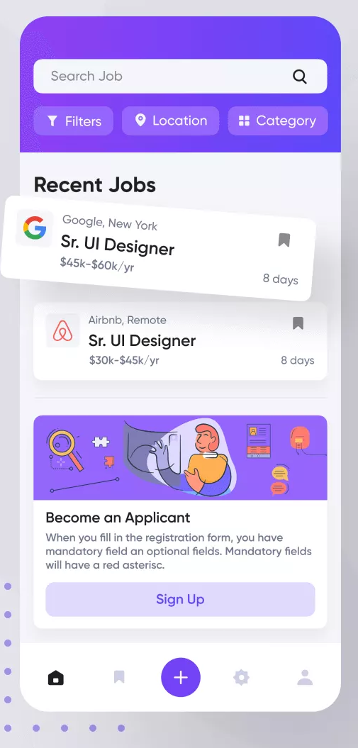**Sign up and login:** Jobfyndr has the feature of registration. User can sign up by creating new account and also login into their previous account.
* **Resume Management:** Job seekers can create and upload resumes by using the option of resume management.
* **Profile Management:** Users can create their profile by mentioning their qualifications, field of interest, previous experiences etc.
* **Schedule Interview:** Through this app set up setup high-quality interviews via video conferencing.
* **Job Alerts:** There are regular job notifications regarding different jobs for job seekers.
* **JOB RECRUITER PANEL:** Graphical user interface, application

  Description automatically generated
* **Job posting:** On the job recruiter panel, employers post various opening jobs that can be related to different fields.
* **Filter Resumes and download:** With the help of this option recruiters can download the resumes of various job seekers and can select the best ones from them.
* **Send Job Invites:** Employers can send written notifications in the form of invitations to the deserving candidate.
* **Payment plan for subscription plans:** There are some subscription plans also available in this recruiter panel that is managed ed by the employer.
* **Sign up or log in via email:** Job seekers can receive a link for registering through email.
* **ADMIN PANEL:**
* **Manage job alerts:** Admin panels main motive to control the functions of this app. It manages notifications in a well-organized manner to make accessibility more effectively.
* **Mange candidate profile:** It also direct the profile of job seekers by keeping them private from other candidates.
* **Invitations:** The admin decides whom to send job invitations that and selects the candidates who desire that job.
* **Recruiter profile management:** Employer profile is also managed by this panel. It keeps the record of every employer.
* **Generate the reports for earnings:** The revenue that is collected through the platform of this app is managed and recorded by the Admin panel.

**Wireframe** 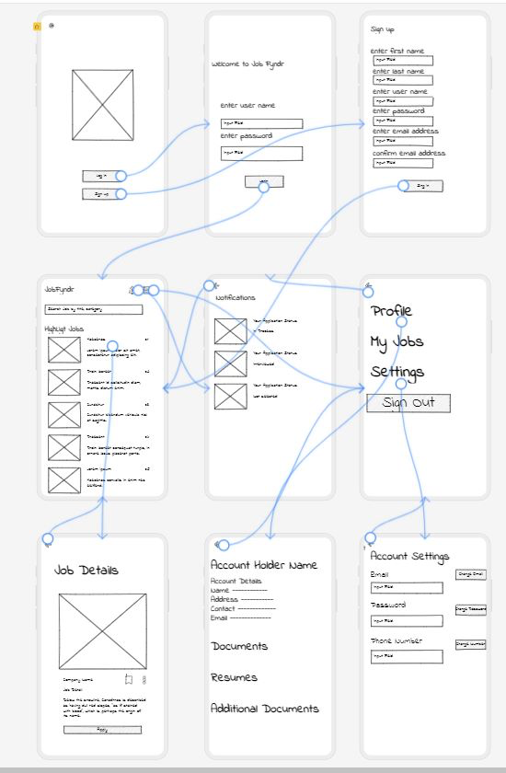

**STRATEGIES COULD BE USED FOR A PLATFORM**

* **Platform**: The application will be released for both the platform Android(Integrated Development Environment (IDE)) and the web portal.
* **Build a pre-launch buzz:** You can create a buzz about the upcoming release of the job-finding application by sharing sneak peeks, behind-the-scenes videos, and other content on social media. This will generate excitement among your target audience and help to build anticipation for the release.
* **Beta Testing:** Launch a beta version of the job-finding application. Invite a select group of users to test the app and provide feedback. This will help you to identify and fix any bugs or issues before the official release. You can also use the feedback to improve the app's features and functionality.
* **Influencer Marketing:** Identify influencers in the job search and career development space and partner with them to promote the app to their followers. Influencer marketing can help you to reach a wider audience and build credibility for the app.
* **Content Marketing:** Create valuable content such as blog posts, articles, and videos that provide tips and insights on job searching and career development. This will attract users to your website and help to establish your brand as an authority in the job search space.
* **Offer a Free Trial:** Offer a free trial of the app for a limited period to encourage users to try it out. This will help users to see the value of the app and increase their chances of them becoming paying users.
* **Launch Events:** Organize a launch event to generate buzz and excitement about the app's release. Invite influencers, media outlets, and potential users to attend the event and showcase the app's features and benefits.
* **Paid Advertising:** Use paid advertising platforms like Google Ads, Facebook Ads, and LinkedIn Ads to reach a wider audience and drive traffic to the app's landing page. This can help to increase awareness and generate more downloads of the app.

**COMPETITIVE RESEARCH AND PLATFORM**

**HOW OUR APPLICATION CAN DIFFERENTIATE FROM OTHERS:**

**Video resume:** In this application, a job seeker can prepare their video resume to make their profile more effective and attractive

Git hub link: Job seekers like coders who are looking the jobs in the field of coding, can attach their self-made projects git hub links to make the recruiter better understand the applier or seeker.

**Effective marketing:** Develop a strong marketing strategy to increase your app’s visibility and attract more users.

Improved user experience: Ensure your app is user-friendly and intuitive, with a clean and straightforward interface.

**STEPS THAT CAN MAKE OUR APP FIT THE MARKET:**

* **Research the Market:** Research the market to understand your target audience, their needs, and preferences. You should also research your competitors and their products to identify any gaps in the market that your application can fill.
* **Develop a Unique Value Proposition:** Use the information you have gathered from your research to develop a unique value proposition that sets your application apart from the competition. This should be a clear and concise statement that highlights the key benefits of your application.
* **Create a Minimum Viable Product (MVP):** Develop a minimum viable product that demonstrates the key features of your application. This should be a functional prototype that you can use to test the market and gather feedback from potential customers.
* **Build a Strong Team:** Building a strong team with a diverse set of skills and experience is crucial for the success of your application. You should have team members who are experts in product development, marketing, and finance.
* **Develop a Marketing Strategy:** Develop a marketing strategy that targets your key audience and highlights the unique value proposition of your application. This should include social media marketing, search engine optimization, and paid advertising.
* **Secure Funding**: Once you have developed a minimum viable product and have a strong team and marketing strategy in place, you can begin seeking funding from investors. This can include venture capitalists, angel investors, or crowdfunding platforms.

**MARKETING:**

**Ways to do Marketing:**

* 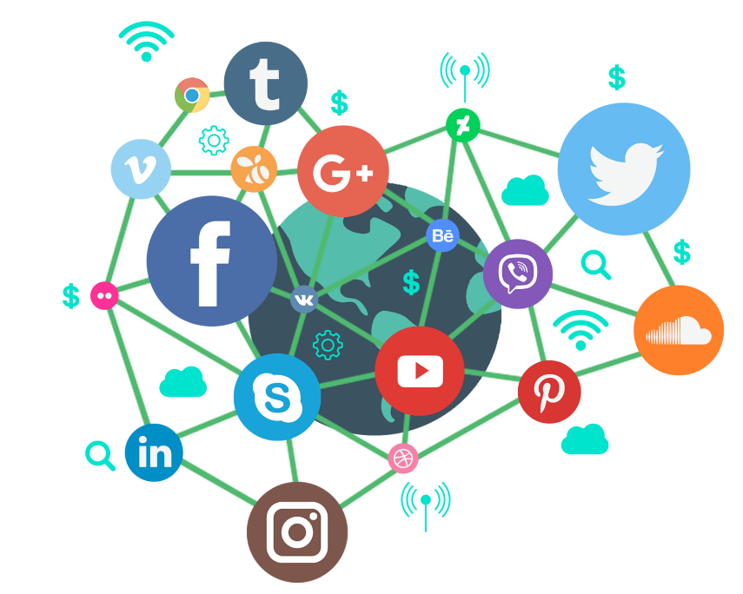**Start a blog:** Regular updates on a topic that focuses on your core service makes you a niche expert, and perhaps worth downloading!
* **Use social media:** But do it wisely; too many people think copying and pasting a link is enough. Engage your audience. Be interesting. Tease. Intrigue. Make yourself click-worthy and share-worthy. Be creative about your intro text.
* **Influencer marketing:** Influencer marketing works because of the high amount of trust that social influencers have built up with their following, and recommendations from them serve as a form of [social proof](https://sproutsocial.com/insights/social-proof/) to your brand’s potential customers.
* **APP STORE OPTIMIZATION**

[App store optimization](https://www.adjust.com/glossary/aso/) is the process of improving your app’s visibility in the App Store and Google Play Store.

**COST, TIME, AND ROI**

**COST:**

An estimated cost for the creation of the application is $50,000.

**Return On Investment:**

Return on investment (ROI) is a metric utilized to assess the effectiveness or profitability of an investment, as well as to compare the effectiveness of multiple investments.

**Time:**

Jobfyndr will be 20 - 30 days.

**HOW IS IT GONNA MAKE MONEY**

**Membership packages:**

This is one of the most effective ways of monetizing a job portal app that results in recurring revenues. As an app owner, you can charge a monthly/annual membership fee for the following:

* Resume access (e.g., access to x number of resumes per month for a certain amount)
* Regular job listings (e.g., x number of job listings per month)
* Access to educational resources related to employee training, recruiting, etc.

**Job Events ticketing & booking:**

You can organize webinars with industry experts who assist job seekers in their career enhancement. These sessions can be very fruitful for the vocational development of an individual.

Job seekers can purchase tickets to the webinars on the job portal itself. This is another effective and interesting way of making money from your job recruitment app.

**E-learning Subscription:**

This is another creative way of increasing your app revenue. You can offer various paid courses that focus on the professional development of job seekers. This can further legitimize your brand as the go-to resource for serious job-seeking candidates.

Make sure to partner with skilled and learned instructors who have adequate industry knowledge. You can even go one step further and offer digital certificates to the candidates that they can showcase on their job profiles.

**SCOPE:**

The scope of the jobfyndr app is to reach a wide range of audience of job seekers who are looking for new employment opportunities. Due to the increase in technology, job search apps become an essential tool for many people who are looking for work.

It has great scope as it provides features such as the ability to search for job openings based on keywords, location, industry, and other criteria.

Apart from that the scope of our app depends upon various factors such as the marketing that is to be targeted and competition in the space. Higher quality of app result in the higher growth and success of app among job seekers.